 Discovery Staging Record Cover Sheet
Date: 2015
Job Developer: Sarah S.
Provider information: BHSSA
Jobseeker: Wayne

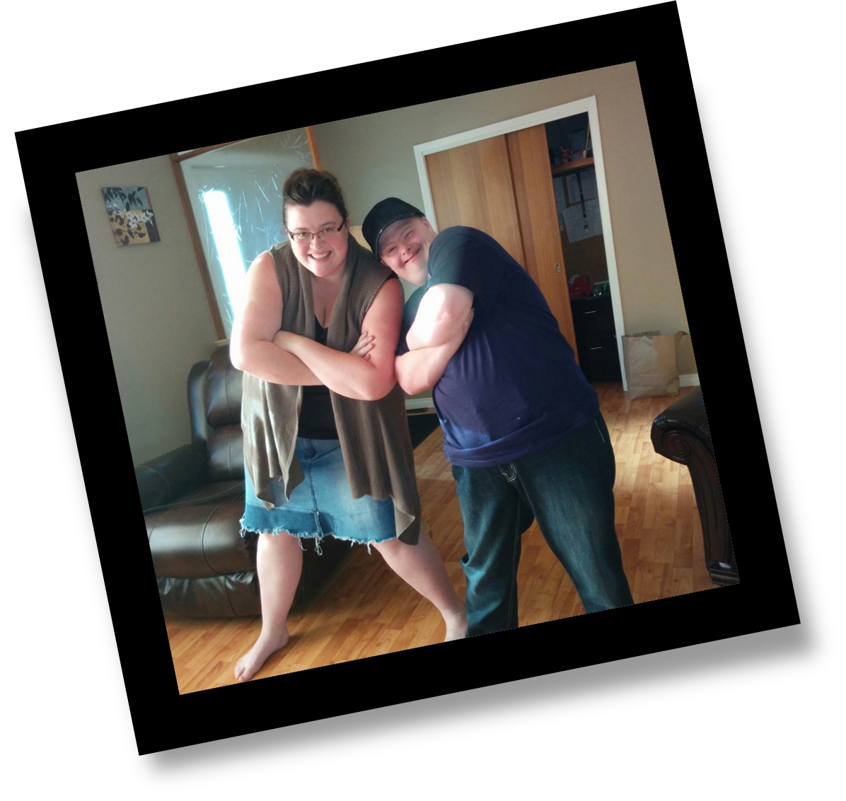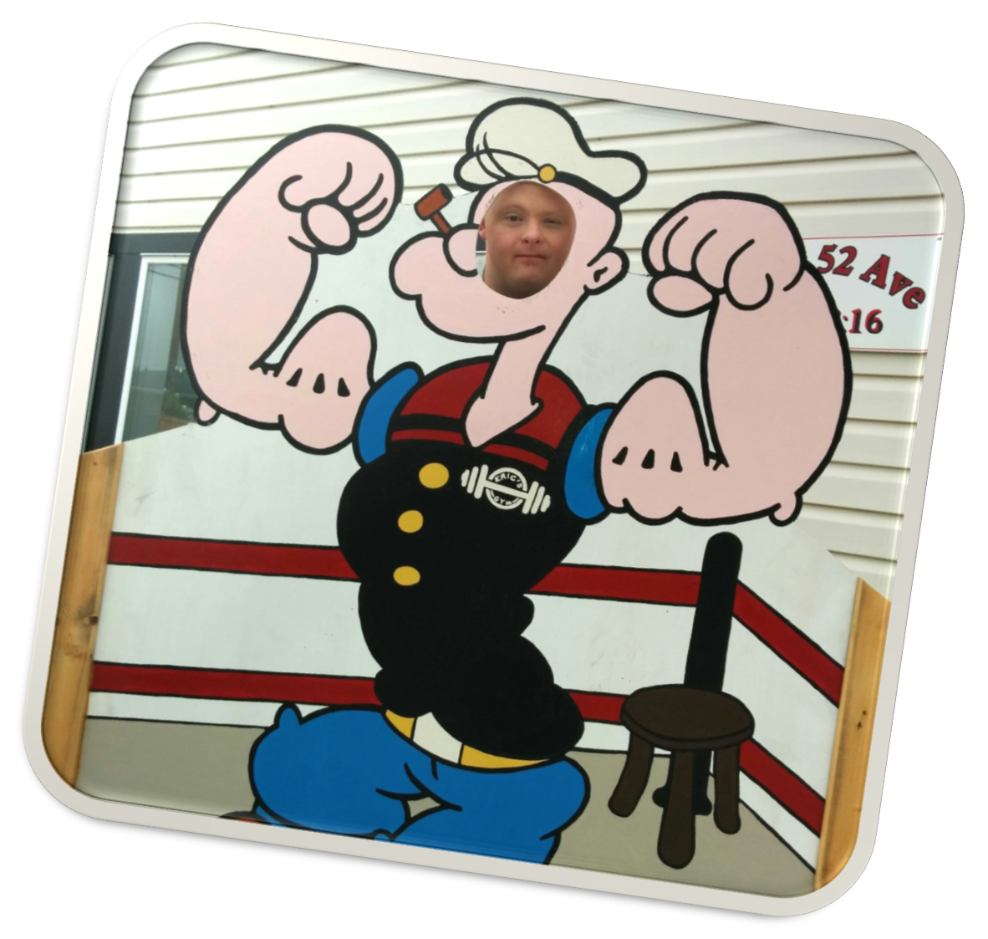

Discovery Staging Record
Instructions: This form is used to stage, structure, capture and record the major events of Discovery. The recorder(s) should pay particular attention to how the tasks are typically performed, any accommodations, technology, supports, or specialized training strategies that should be employed. Handwritten discovery notes should be used in the field during the discovery activity with information summarized here. NOTE: The DSR is a flexible document, changing as situations change. Feel free to update it when needed, but be sure to insert any new/updated information into the form fields WITHOUT overwriting or erasing the original information you entered. That way the DSR will keep a record of the original activities and in chronological order, the newest changes. Here is how to insert: return to the beginning of the section where the new information will be added. Place the curser above the existing information and type in the new date followed by the newest discovery information. The old information should stay in place. A quality DSR has more verbs than adjectives. It describes the development and observations of activities.
Name: Wayne
Date started April 2015 Date completed: Aug 2015
Family Contacts: Josh (brother)
Phone: xxx-xx-xxxx E-mail: josh@gmail.com
Person(s) completing Discovery Record: Sarah S
Additional Contact Information:
Team Members and Responsibilities:
Wayne (Job Seeker), Sarah (Employment Specialist), Karina (Employment Specialist)
Consultants/Experts to Contact: Janet (CE Project Consultant)

Stage One: Home & Neighborhood Observation

This section includes “relevant” information not only from interviews and conversations but from your observations.
Who will ensure this stage is completed? Sarah S
By what date? May 2015
Preliminary step: review records, files, assessments to establish current issues, cautions, training, etc., that may be of relevance:
Went through personal Files. Wayne is verbal but has trouble with pronunciation, He gets frustrated when people don’t understand him and will give up or when asked a question he will just say “I don’t know”. He has bouts of depression and often will isolate himself. He really likes food and will often sneak food and over eat.
Initial Interviews: Begin with the individual’s home and/or family home (if residing there).
Date: May 10, 2015
Recap of Information (attach field notes, pictures): Wayne LOVES his movies he must have close to 500 if not a bit more. He seems to have a place for each one. Family seems important to him has pictures of them. He has quite a few pictures of animals. He is very proud of his jerseys and he is an avid Oilers fan and knows of Joey Moss (not sure if he met him could not understand) He lives with two roommates -- one is the same age as him and shares similar interests and the other is a few years older. The three of them have lived together for a while. Wayne really likes music and has a collection almost as impressive as his movie collection.
Observations of home, bedroom, property, belongings that seem relevant: Wayne has a Lot of movies and he is very proud of them. His area is kept very neat and tidy. He does not like a mess.
Specific chores & tasks performed at home: Cooks, grocery shops, cleans, does laundry
Hobbies, Sports, Collections, Interests noticed during home visit: Has bowling trophies and has hockey jerseys, Collects movies and music (country)
Family/friend/community activities individual engages in and regularity: Josh(brother), Tyler, Darwin, Marvin, Lyle, Leigh, Special O bowling, Swimming, Going to the movies
Neighborhood Mapping (resources, employers, transportation options, neighbors of interest, activities, civic engagement): Lives close to down town. Lives at the end of the street not a lot of neighbor interactions.
Talents, interests, skills, and tasks observable/revealed: Likes to pull pranks on staff and others, good cook
Activities, situations, & locations that need to be avoided: none known at this time

Stage Two: Others to be Interviewed
- Name: Josh
Relationship/role: Brother
Person responsible: Sarah By this date: 5/17,15
Date accomplished 515/15
What was learned? Wayne wants to feel needed, and likes to help others. He was adopted. Likes animals, Likes food, Memory not the best
- Name: Ann
Relationship/role: Friend from child hood
Person responsible: Sarah By this date: 5/17/15
Date accomplished 5/16/15
What was learned? Likes to play pranks on people. Likes to help others. Likes to have fun. Wayne is not afraid of work.
- Name: Corrinne
Relationship/role: Support staff
Person responsible: Sarah By this date: 5/17/15
Date accomplished 5/15/15
What was learned? Has done a lot of cleaning in the past, Does well on own, likes animals.
- Name: Tim
Relationship/role: Past supervisor of program
Person responsible: Sarah By this date: 5/17/15
Date accomplished 5/17/15
What was learned? Likes to feel needed and likes when you ask for his help. Likes to have fun. Likes animals. Enjoys cooking

Patterns Emerging: (Tasks, Interests, Talents & Skills): Animals, Helping Others, Cooking

Stage Two: Discovery Visits
Identify approximately five places where this individual can be observed in activities that give context to their Interests, Talents & Skills – TAKE PHOTOS.
- Organizing videos at home
Person responsible: Sarah By this date: 5/25/15
Date accomplished 5/18/24
- Cooking-.
Person responsible: Sarah By this date: 5/25/15
Date accomplished 5/18/15
- Grass cutting-
Person responsible: Sarah By this date: 6/1/15
Date accomplished 5/28/15
- First Aid Class
Person responsible: Sarah By this date:

Observations ( I put theses in the section above)
Note your observations for each location, date, the specific tasks engaged in, skills utilized, and specific supports needed:
- Location: Home
Date: 5/2015
Tasks: Organizing movies - I asked Wayne to pick 10 of his most favorite movies, and wanted to see how he put them back. He put all 10 back in their exact spots!
While we did this activity, I was also trying to identify interests, as Wayne has been saying he wants a cleaning job. With Wayne’s limited verbal skills, I thought that having him pick some movies would show me what his real interests are. Wayne picked 3 types of movies: 1) movies that made him feel excited/scared, 2) movies where people received help; and 3) movies about animals being cared for.
Supports Needed: He was very independent at organizing the movies! We had sat and talked for about an hour so I would say that his memory is not bad (if it is something that interests him!).
- Location: Cooking at home
Date: 5/18/15
Tasks: Wayne made muffins from a box mix. He followed the recipe on the box (with pics) and was very safe. Staff report he can follow simple written recipes, but would rather make it up as he goes. He can read if he takes the time, and pictures to supplement are helpful. He wanted to eat all that he baked after it was done
Supports Needed: Simple recipe, pictures.
- Location: Mowing grass at home with a gas lawn mower.
Date: 5/25/15
Tasks: Wayne did very well with minimal prompts. I asked him about safety and he told me knows how to run the machine safe.
Supports Needed: He was fairly independent, but needed reminders to get into the “corners” . He also need a bit of help refilling the gas when it ran out.
- Location: First Aid Class through People First
Date: 5/28/15
Tasks: Wayne like helping people so we had him take a first aid course offered by People First. He enjoyed the class and is really proud of his certificate! He has been telling everyone about it.
Supports Needed: Wayne need a bit of support around reading when he took the class. And we practiced with him before the class
Summary of supports needed during these activities (be specific): Needs some prompts to complete. Pictures might be helpful, but once he has a routine down, this would not be needed.
What environments & activities need to be avoided and why? While cooking is an interest, he tends to sneak food and get fixated about it
What places, skills and activities need more exploration? Helping People, “adrenaline”, animals, organizing
Where/when will this exploration occur? Will visit the EMS and fire department
Who is responsible? Sarah
Report on follow-up exploration (Report each follow up activity with the date and descriptive narrative. Include what was learned, who participated, and the name of the person responsible for the activity): (see below – informational interviews)

Stage Three: Vocational Themes

(not job descriptions or business ideas)

Emerging themes that meld Tasks, Interests, Talents, and Skills:
- Advocacy (helping people)
- Animals
- Emergency/Crisis Services – “Adrenaline”
- Also Organization, Entertainment, Sports

Identify 3 places for each theme where people with similar themes work:
Theme 1:
- Hospital
- Assisted Living Facility
- Library
Theme 2:
- Veterinarian
- Farm
- Pet Store
Theme 3:
- Fire department – also fits with theme one
- EMS – Also fits with theme one
- Hospital

Select and Arrange Informational Interviews to Add to Discovery
(Including short, preferably paid, work experiences in businesses or non-profits)
- Location: Barrhead Emergency Medical Services
Person responsible: Sarah By this date: 6/15/15
Date accomplished 6/12/15
Observations: Wayne seemed interested as Darren, EMS Supervisor, showed us around. He talked about the training that EMT’s go through. He showed us the ambulance and all the equipment in the back. He had Wayne sit in the driver’s seat and showed him how the siren and lights worked. He also had him help with the gurney and had him help maneuver the gurney into the back of the ambulance using the hydraulic lifts. We were not able to identify current needs that were a match with Wayne’s skill, other than potentially cleaning tasks.
- Location: Barrhead Fire Department
Person responsible: Sarah By this date: 6/15/15
Date accomplished 6/15/15
Observations: Fire Chief John met with us and told us about he got into the field – he rode around with police, EMT’s and Fire Department staff to get an idea of what he wanted to do. He decided on a job with the Fire Department. He described tasks which always need to be done, including rolling fire hoses, putting away materials after fires, and helping at fires. He explained that “volunteer” fire fighters ARE paid. Hours vary, but they have regular training once a week. The Fire Department culture is like family – there is a gym they can work out in, a kitchen, etc. People are very close and help one another when in need. The Fire Department also does a lot of community service work – BBQs, fund raisers, etc.
Wayne seemed very comfortable at the fire department and liked Fire Chief John. He was very engaged and interested through the meeting and tour, and answered questions that Chief John had for him. Fire Chief John told him to think about whether he wants to work there, and if so, to come see him in two weeks.
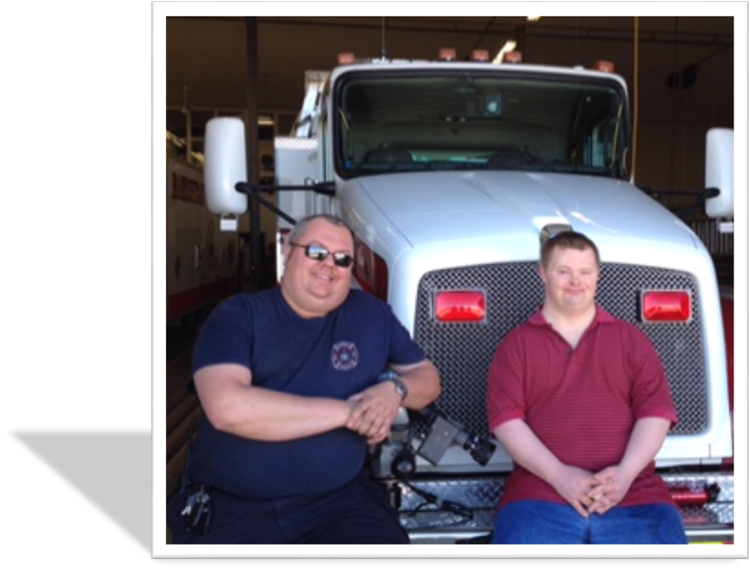

Stage Three: Vocational Profile
Summarize findings from Discovery and include the following in your description. If a clear direction is identified
- Interests, Talents, Skills, Tasks as observed; best ecological fit; best learning mode/methodology; places/situations to avoid; personal resources (benefits, family support, savings, transportation); most endearing/engaging qualities; exploitable skills: Wayne needs to be in job where he can help others. He also would benefit from a supportive work environment, that is fun and he gets to interact with others. He lives close to town, and staff can provide transportation if needed. Avoid places where he would be working alone or isolated.
- Ideal Conditions of Employment: Employed in a team setting where people are helping others and supportive of one another.
- What “off the job” support will be needed and who will provide? Wayne has residential staff that can prompt him to get ready for the day. He will likely need support with getting ready for work (getting out on time, dressing appropriately, making his lunch, etc.) especially initially, depositing checks/banking.
- How will this person stay in contact with their friends, and who will ensure this? He sees friends through home activities, Special Olympics, and other activities. Sarah
- How will this person get to and from work? Will use fast start funds to buy a bike.
- What is this person’s ideal work schedule (days and hours) and why? Does not matter, but days are preferable.

Stage Four: Job/Business Development Plan
Note that in many States this Stage is not funded under Discovery/Assessment. This Stage instead signals the beginning of the Job Development and/or Career Planning Milestone.

List of Twenty Places where people with similar Vocational Themes Work:
Theme 1:  Advocacy  - Hospital  - Hillcrest  - Keir care (Elder care)  - Blue Heron  - FCSS  - Health Clinics  - Alberta Health Services  - Massage place  - Fire Department  - Police Department  - EMS | Theme 2:  Animals  - Veterinary  - Rescue shelter  - Pet store  - Goat farm  - Honeyville ranch  - Grange  - R&R Pet Resort  - Dog Breeder (off 2nd St) (or self-employment?)  - Pet Walking or Pet Sitting (Self-Employment) | Theme 3:  Emergency Services (“adrenaline”)  - Police  - Fire Department  - EMS  - Hospital
Note: Create representational portfolios, picture books, resumes, and other tools for job development as needed.
Person responsible: Sarah
By what date: 6/30/15 Date completed:

DSR Final Approval Signatures For Discovery
NOTE: From this point forward you will continue to use the format described in Stage 4 to report all job development activities for wage employment.
For self-employment or business-within-a-business you will report through narrative case notes, submission of a business plan, and any negotiations documenting job development.
DSR Final Approvals Signatures in this section are done when the jobseeker and others decide this DSR answers the question “Who is this person?”, and all Team members agree to the direction the job development plan is going. This signals the end of Discovery and the jobseeker moves into job development and placement activities.
Participant: Date:
Conservator/Care Provider: Date:
VR Counselor Signature: Date:
ACRE Certified Customized Employment Specialist: Date:
Vocational Manager: Date:

Stage Four: Informational Interviews for Job Development
Utilizing information gained during Discovery and summarized in this DSR, select 3 or 4 businesses from the list above and arrange Informational Interviews, or short-term Work Experiences, Internships, and Modified Apprenticeships for job development
- Business Name: Barrhead Fire Department
Person responsible: Sarah
By this Date: July 5, 2015 Date completed: July 3, 2015
Contact person and title: John W. Fire Chief
Phone: xxx-xx-xxxx ext. xxx e-mail: John@firestation.com
Notes: John asked Wayne to think about working there for 2 weeks, and come back if he is interested. He’s interested!!!
Information Learned: Met with John again. They are actively recruiting and they will help find where the person belongs on the team. We discussed some of the duties that Wayne could start out doing (rolling fire hose, general organization and clean up), as well as tasks that he could grow into over time (going out on fire calls).
Negotiation Notes: To go out on fire calls, he needs to be able to get his bunker gear on in 1 minute or less. He needs to be available for Thursday evening staff training. We reviewed a tentative start date, pre-employment paperwork (background check, etc.), and support to be provided by Blue Heron Support Services.
Follow up (what, who and by when): Sarah and Wayne
Need to get background check and child welfare check completed – Wayne and Sarah.

- Business Name:
Person responsible:
By this Date: Date Completed:
Contact person and title:
Phone: - ext. e-mail:
Notes:
Information Learned:
Follow up (what, who and by when):
Negotiation Notes: Date: Notes:

DSR Final Approval Signatures
NOTE: DSR Final Approval Signatures in this section are done when the jobseeker and others agree on the job (development) placement negotiated outcomes, outlining the specific strategies to be implemented for successful employment (i.e.; self-employment, wage employment, resource ownership, supported employment, customized work activities or schedules, etc.).
Participant: Date:
Conservator/Care Provider: Date:
VR Counselor Signature: Date:
ACRE Certified Customized Employment Specialist: Date:
Vocational Manager: Date:
This document is locked, but can be modified by the user. Agency logos and identifiers, specific data fields and codes can be added, but the process should remain relatively unchanged to maintain fidelity to the DPG process. Please e-mail Meg Hammis at mhammis@griffinhammis.com or any GHA staff member for assistance with unlocking the form and for guidance in editing. The identification of Griffin-Hammis Associates, Inc. and/or the Center for Social Capital, Inc. must remain prominent on the form.

